Fuel Your Fitness: The Ultimate Protein Shaker Bottle by Kings Gym

When you’re chasing fitness goals, every detail counts. From the reps you grind out to the nutrients you consume, precision is key. That’s why Kings Gym’s Protein Shaker Bottle isn’t just a gym accessory; it’s a game-changer for your workout routine.

Why You Need a Top-Tier Shaker Bottle
Imagine hitting the gym or heading out for a run, only to struggle with a clumpy protein shake. It’s frustrating and undermines the effort you put into your fitness journey. A high-quality protein shaker ensures:
- Smooth, lump-free shakes with every mix.
- On-the-go convenience for busy lifestyles.
- Improved hydration with easy-to-carry, spill-proof designs.
The Kings Gym Protein Shaker Bottle takes these essentials to the next level.

Why a Quality Shaker Bottle Matters
A reliable shaker bottle is more than just a container. It’s your go-to for mixing protein shakes, staying hydrated, and fueling your body post-workout. A poorly designed shaker can lead to clumps, leaks, or a less-than-perfect experience. That’s why Kings Gym has designed a shaker bottle that combines function, style, and durability to support your fitness journey.

Features That Set Kings Gym’s Protein Shaker Apart
What makes the Protein Shaker Bottle stand out in a sea of fitness accessories? Let’s break it down:

1. Leak-Proof Design
No one wants a bag drenched in protein shakes. The shaker’s secure screw-on lid and snap-tight cap ensure zero spills, even when you’re on the move.

2. Premium Mixing Technology
Say goodbye to clumps! With a robust mixing ball or grid, this shaker guarantees smooth blends for protein powders, meal replacements, or hydration drinks.

3. Durable and BPA-Free Material
Crafted with high-quality, BPA-free plastic, this shaker is safe for your health and built to withstand daily use without cracking or fading.

4. Ergonomic and Stylish Design
Sleek, comfortable to hold, and branded with the Kings Gym logo, this shaker is as functional as it is eye-catching. You’ll love flaunting it at the gym or during outdoor workouts.

5. Generous Capacity
With enough space to hold your post-workout shake, pre-workout boost, or daily hydration needs, this bottle is a versatile fitness companion.
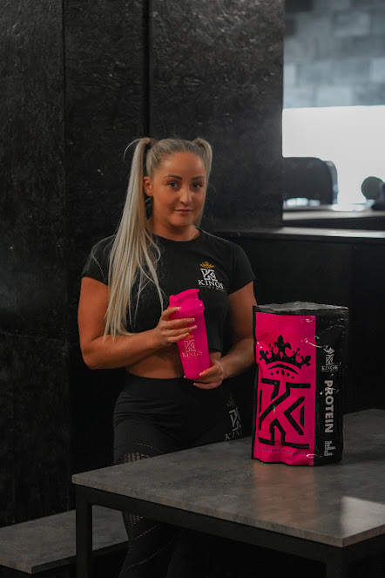

How to Make the Most of Your Protein Shaker Bottle
A shaker bottle isn’t just for protein shakes. Here’s how you can maximize its use:
- Post-Workout Nutrition: Mix your favorite protein powder with water or milk for quick recovery.
- Pre-Workout Boost: Prepare energy drinks or BCAAs to fuel intense sessions.
- Daily Hydration: Infuse water with fruits for a refreshing twist.
- Meal Replacements: Blend meal replacement powders for quick, nutritious meals.

Why Choose Kings Gym?
At Kings Gym, we’re not just about fitness gear; we’re about building lifestyles that promote strength, health, and confidence. Our protein shaker bottle embodies this philosophy. It’s not just a product; it’s a tool to help you reach your fitness aspirations with style and efficiency.

Grab Your Protein Shaker Bottle Today!
Ready to elevate your fitness game? The Kings Gym Protein Shaker Bottle is waiting for you. Durable, stylish, and designed for performance, it’s the ultimate accessory for fitness enthusiasts who demand the best.
Don’t settle for less when it comes to your health. Shop now and make every sip count!

Level Up Your Fitness Game
Ready to take your fitness routine to the next level? The Kings Gym Protein Shaker Bottle is the perfect addition to your gym bag. Whether you’re blending up a protein shake post-workout or staying hydrated during a cardio session, this shaker bottle is here to make your life easier and your fitness journey smoother.

Get Yours Today!
Don’t settle for less when it comes to your fitness gear. Shop the Kings Gym Protein Shaker Bottle now and experience the difference of quality and performance in every sip.

