Snowmobile Tours in Michigan: Explore the Winter Wonderland with Boyne Recreational Rentals
Winter in Michigan is nothing short of magical, and there’s no better way to immerse yourself in its snowy splendor than by hitting the trails on a snowmobile. Whether you’re an adrenaline junkie or just looking to explore the serene beauty of the winter landscape, Boyne Recreational Rentals has you covered with their top-notch snowmobile tours.

Why Snowmobiling in Michigan?
Michigan is a paradise for snowmobile enthusiasts. With over 6,000 miles of groomed trails that wind through forests, across frozen lakes, and over rolling hills, it’s easy to see why this state is a top destination for winter sports. The sheer variety of trails means there’s something for everyone, from easy rides perfect for beginners to challenging routes that will test even the most experienced riders.

Boyne Recreational Rentals: Your Gateway to Adventure
Boyne Recreational Rentals is your one-stop shop for all things snowmobiling in Michigan. Located conveniently near some of the best trails in the state, they offer everything you need for a memorable adventure.

Top-of-the-Line Snowmobiles
At Boyne Recreational Rentals, you’ll find a fleet of the latest snowmobiles, all meticulously maintained to ensure a smooth and safe ride. Whether you’re a seasoned pro or a first-time rider, their selection of snowmobiles caters to all experience levels. Feel the power beneath you as you glide through Michigan’s winter wonderland.

Guided Tours for All Skill Levels
Never been on a snowmobile before? No problem! Boyne Recreational Rentals offers guided tours that are perfect for beginners. Their experienced guides will lead you through some of the most scenic trails, providing tips and ensuring you’re comfortable every step of the way. For the more experienced riders, they also offer advanced tours that explore more challenging terrain.

Customizable Experiences
Want to make your snowmobile tour even more special? Boyne Recreational Rentals offers customizable experiences to fit your needs. Whether you’re planning a family outing, a romantic adventure, or a group trip with friends, they can tailor the tour to your preferences. Picture yourself riding through the snow-covered forests, the crisp winter air in your lungs, and the sound of the snow crunching beneath your snowmobile – it doesn’t get better than this!
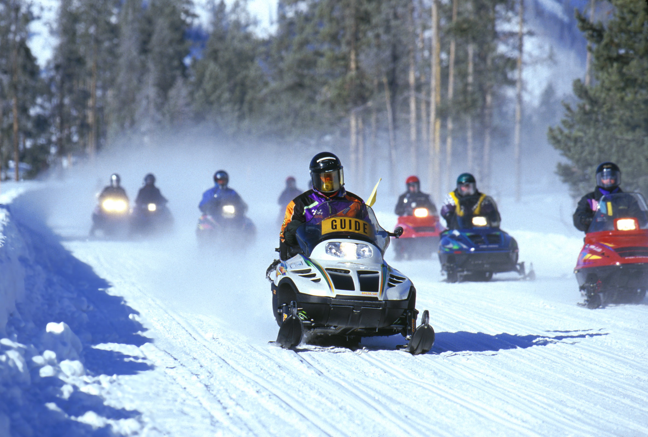

The Ultimate Winter Experience
Michigan’s winter landscape is a sight to behold. Imagine cruising through tunnels of snow-laden trees, with nothing but the sound of your snowmobile and the occasional call of a winter bird breaking the silence. You’ll pass frozen lakes, where the ice sparkles like diamonds under the winter sun, and open fields where you can pick up speed and feel the exhilaration of the ride.
But it’s not just about the thrill – it’s also about the peaceful moments. There’s something incredibly serene about being out in nature, surrounded by snow, with no one else around. It’s a chance to disconnect from the hustle and bustle of everyday life and reconnect with the beauty of the natural world.

Safety First
At Boyne Recreational Rentals, safety is a top priority. Before you head out, their team will provide a comprehensive safety briefing, ensuring you know how to operate your snowmobile and what to expect on the trails. They also provide all the necessary gear, including helmets and warm clothing, so you can focus on enjoying the ride.

Book Your Snowmobile Tour Today!
Don’t let another winter pass by without experiencing the thrill and beauty of snowmobiling in Michigan. Boyne Recreational Rentals makes it easy to book your tour, with options for half-day, full-day, and multi-day adventures. Whether you’re a local or just visiting, this is one winter activity you won’t want to miss.

Conclusion
Snowmobiling in Michigan is more than just a ride – it’s an adventure that takes you deep into the heart of winter’s beauty. With Boyne Recreational Rentals, you’re not just renting a snowmobile; you’re creating memories that will last a lifetime. So why wait? Grab your gear, hit the trails, and discover the magic of Michigan’s winter wonderland today!

